SF.SmokeTestScripts_TC_SF_OBRequiredFieldsOnSalesStage_Instance1_12-Apr-2017_04-56-28_PM_Invoke_Application.png



SF.SmokeTestScripts_TC_SF_OBRequiredFieldsOnSalesStage_Instance1_12-Apr-2017_04-56-38_PM_Login.png

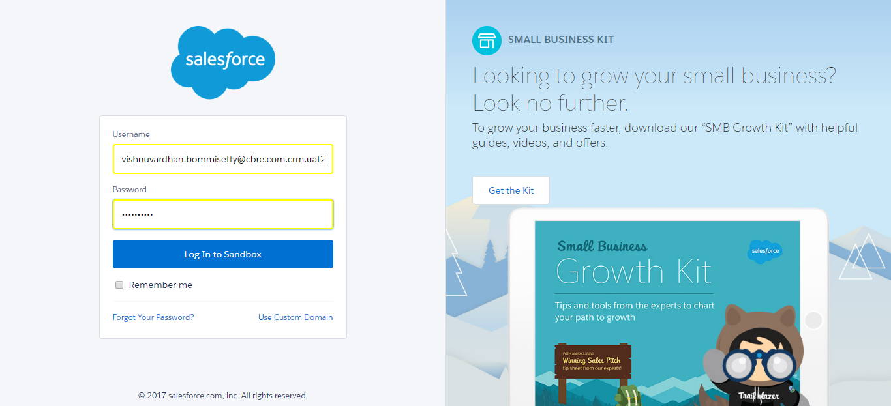

SF.SmokeTestScripts_TC_SF_OBRequiredFieldsOnSalesStage_Instance1_12-Apr-2017_04-56-49_PM_Verify_Login.png

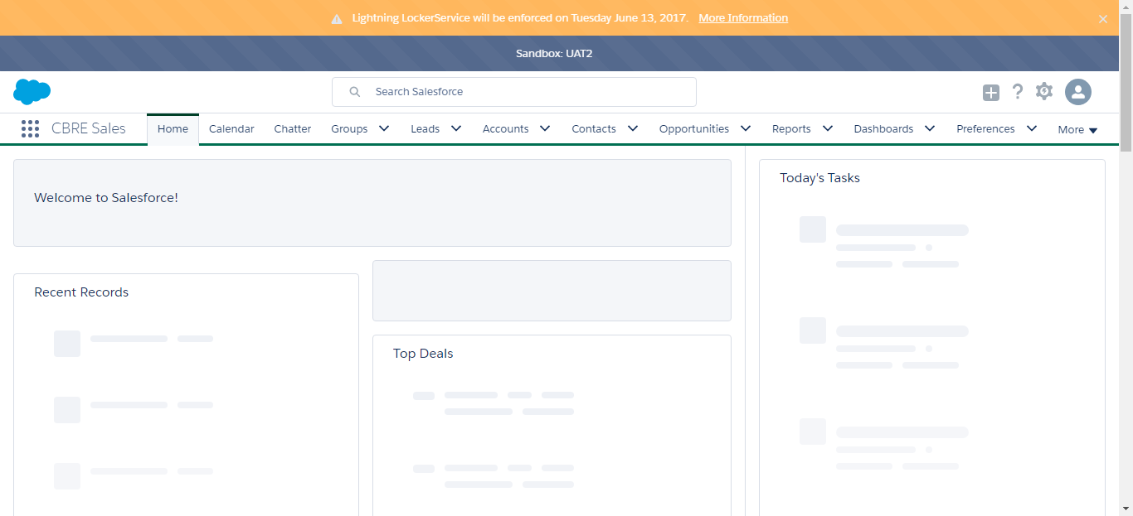

SF.SmokeTestScripts_TC_SF_OBRequiredFieldsOnSalesStage_Instance1_12-Apr-2017_04-56-51_PM_Verify_Fetch_Record.png

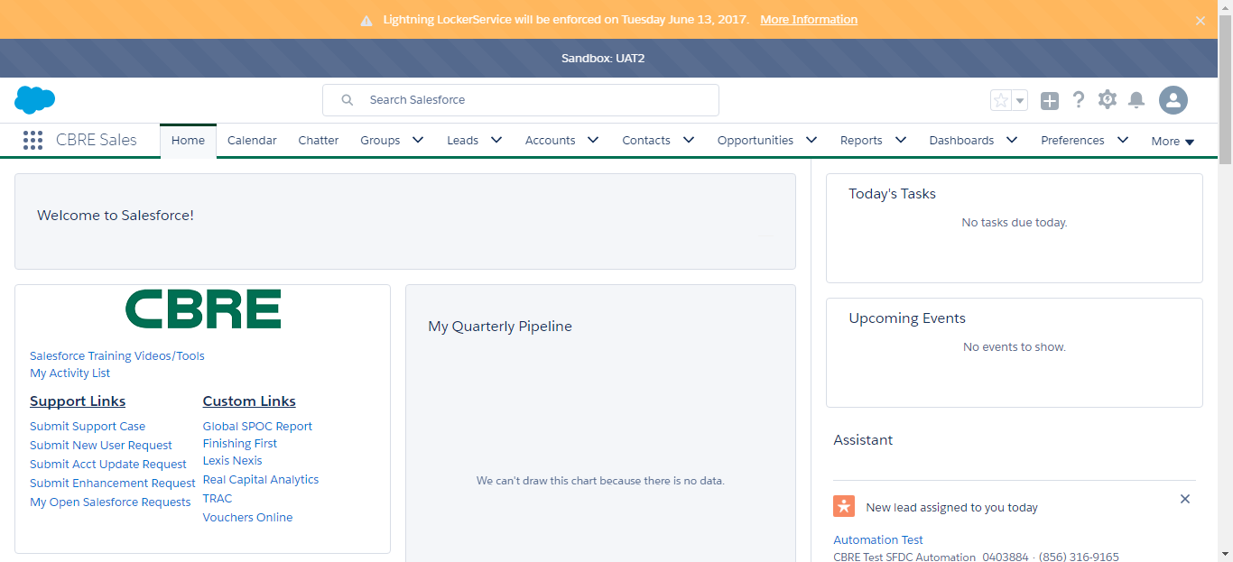

SF.SmokeTestScripts_TC_SF_OBRequiredFieldsOnSalesStage_Instance1_12-Apr-2017_04-56-56_PM_Verify_Add_Opportunity_Page



SF.SmokeTestScripts_TC_SF_OBRequiredFieldsOnSalesStage_Instance1_12-Apr-2017_04-56-56_PM_Verify_Opportunity_Required



SF.SmokeTestScripts_TC_SF_OBRequiredFieldsOnSalesStage_Instance1_12-Apr-2017_04-57-14_PM_Verify_Add_Opportunity_Page

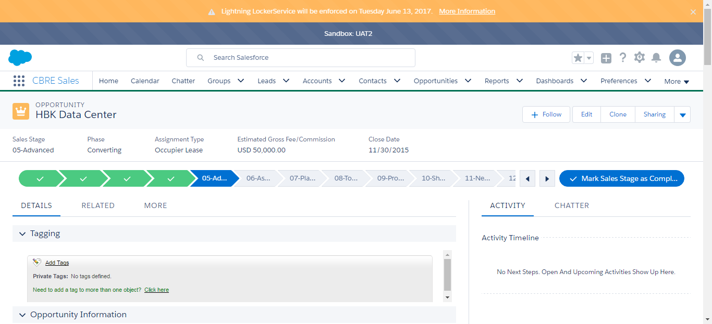

SF.SmokeTestScripts_TC_SF_OBRequiredFieldsOnSalesStage_Instance1_12-Apr-2017_04-57-15_PM_Error.png

